**TABLE OF CONTENTS**

1. **INTRODUCTION**
   1. Concept
   2. Project Scope
2. **PLANNING**
   1. Approach
   2. Agile Development Techniques
   3. Group Management
   4. Technologies Used
3. **RESEARCH & ANALYSIS**
   1. Early Assumption Testing
   2. Market Analysis
   3. Stakeholder Analysis
   4. Design Heuristics
4. **APPLICATION REQUIREMENTS**
   1. Functional Requirements
      1. System Requirements
      2. User Requirements
   2. Non-functional Requirements
5. **PROTOTYPING & ITERATION**
   1. Concept
   2. User Interface
   3. Name
   4. Homepage Page
   5. Reviews
   6. Profiles
6. **SYSTEM DEVELOPMENT**

**(Detail focused)**

* 1. Agile Project Techniques
  2. Development of Source Code
     1. Front-end
     2. Back-end
     3. APIs
     4. Data Structures
  3. Test-driven Development
  4. Unit Tests
  5. TDD Practice

1. **DISCUSSION**
   1. Thematic based analysis
   2. Concept based analysis
2. **EVALUATION**
   1. Technical Difficulties
   2. Teamwork and Management
   3. Aims Reached
   4. Going Forward
3. **CONCLUSION**
4. **USER GUIDE**
5. **INTRODUCTION**

**1.1 Concept**

As per our proposal, our aim is to develop a web application that ranks the universities in London. Unlike other university ranking sites, we will use social aspects such as crime, transportation, and societies in addition to courses and modules, to form of how we rank the universities. The users of this application can use this site to help them decide where they want to study in London.

We will try to use APIs to gather data from external sites to help us build a ranking system as we do not currently have any data of our own to build an accurate list. We will also use a star grading system based off reviews left by users to rank the courses and modules. Users will be required to log in via their university credentials to leave a review.

**1.2 Project Scope**

Before we could decide on a minimum viable product (MVP), we developed a backlog to help us prioritise what were the most important features needed for this web application to function as we intended. Core functionality would look as follows:



We then broke down what is done at each step:

From this we prioritised the features that were most important, these are highlighted in grey.

As a minimum viable product (MVP), we aim to produce a web application that allows the user to view the current rankings of universities in the UK. As we do not currently have any data of our own to base the rankings from, we will be using data from an external site (The Complete University Guide, <https://www.thecompleteuniversityguide.co.uk/league-tables/rankings>) which already has this information. They use the following metrics for their rankings; overall ranking, entry standards, student satisfaction, research quality and graduate prospects, they also allow the user to choose a category is more important to them and see the rankings based on their selection. The user should also be able to read reviews left by other users and be able to submit a review if they wish, we will also include a contact page. Below is a detailed breakdown of these features and addition features we would like to include should the initial MVPs be met.

**MAIN MVPS**

**Homepage**

This will be our landing page where the user will see an up-to-date list ranking the universities in the UK. This will be achieved through the use of APIs. Here, they can sort via the 4 subheadings: Overall score, Student Satisfaction, Social and Graduate prospects. By default, the rankings will be sorted by Overall score.

**Reviews Page – Read reviews**

This page will allow the user to read reviews left by other users and see how they have ranked subjects or social aspects.

**Reviews Page – Submit reviews**

Within the read reviews page, there will be an optional text box for users to submit their own rankings, to do this the user will need to create a profile.

**Profile Page**

Users who wish to leave a review can create their profile here, providing a name and surname.

**Contact Page**

Users can contact any of the team members via the details given on the page. As a minimum we will include email, telephone, and an address.

**ADDITIONAL FEATURES**

**Profile Page**

If the initial MVP for this page is met, we will aim to develop the profile page, and include a login system that requires the user to enter their university credentials so that we can verify them. This will help avoid discriminatory reviews being left by the user. Having verified users also protects the integrity of the site and information submitted.

**Contact Page**

We will include a map to assist users with finding our location,

1. **PLANNING**

**2.1 Approach**

The intention was to meet on a weekly basis, this would give us time to work on our individual tasks and the meetings would be an opportunity for troubleshooting and to review if our current plan was working or if any changes needed to be made.

* 1. **Agile Development Techniques**

We looked at agile development techniques to help us plan how we would work on this project. We decided that Kanban’s and Test-driven development (TDD) were important for us to achieve our end goal. Using a kanban, would allow us to visualise how much progress we are making and keep track of work that needs to be done.

We created our first Kanban using a platform called Asana. Here, we can see who is responsible for what task, set deadlines for individual task, set, follow-ups task and much more.

Test driven development will be an important part of our development, used regularly to measure our progress and functionality of the web application. For each stage of the TDD we would need to write some tests that we expect to fail, run the tests against our software and refactor the code accordingly.

We will also use User-feedback as part of our testing as we want to ensure the user requirements are being met and that we are working in line with the proposal.

**2.3 Group Management**

Our first group meeting was to discuss each other’s strengths and weakness, and how we can best utilise our skills to build our web application. As there were 7 members of the group, we decided it best to have 2 groups of 2, and one group of 3 working on separate tasks.

The first group would be working on the rankings page; this would be the landing page for the website and the first page users will see. We considered that the rankings could be linked to student reviews but as there won’t be enough reviews initially to generate accurate rankings, we would need to do some research on APIs and try to work out how to use it within our software so that we can provide accurate rankings.

The second group will be working on the reviews page, this could be split into two separate pages; one for the reviews and another for the user to leave a review. We agreed that we would for now, try and create it as one page to meet our initial MVP.

We agreed that the forum page required more people working on it as it would be a more complex task than the others; we would need to build a database to hold the information in addition to creating the actual page in html.

**2.4 Technologies Used**

We are using GitHub for version control, with all group members added as collaborators. We created a repository and uploaded our iterations of our MVPS here.

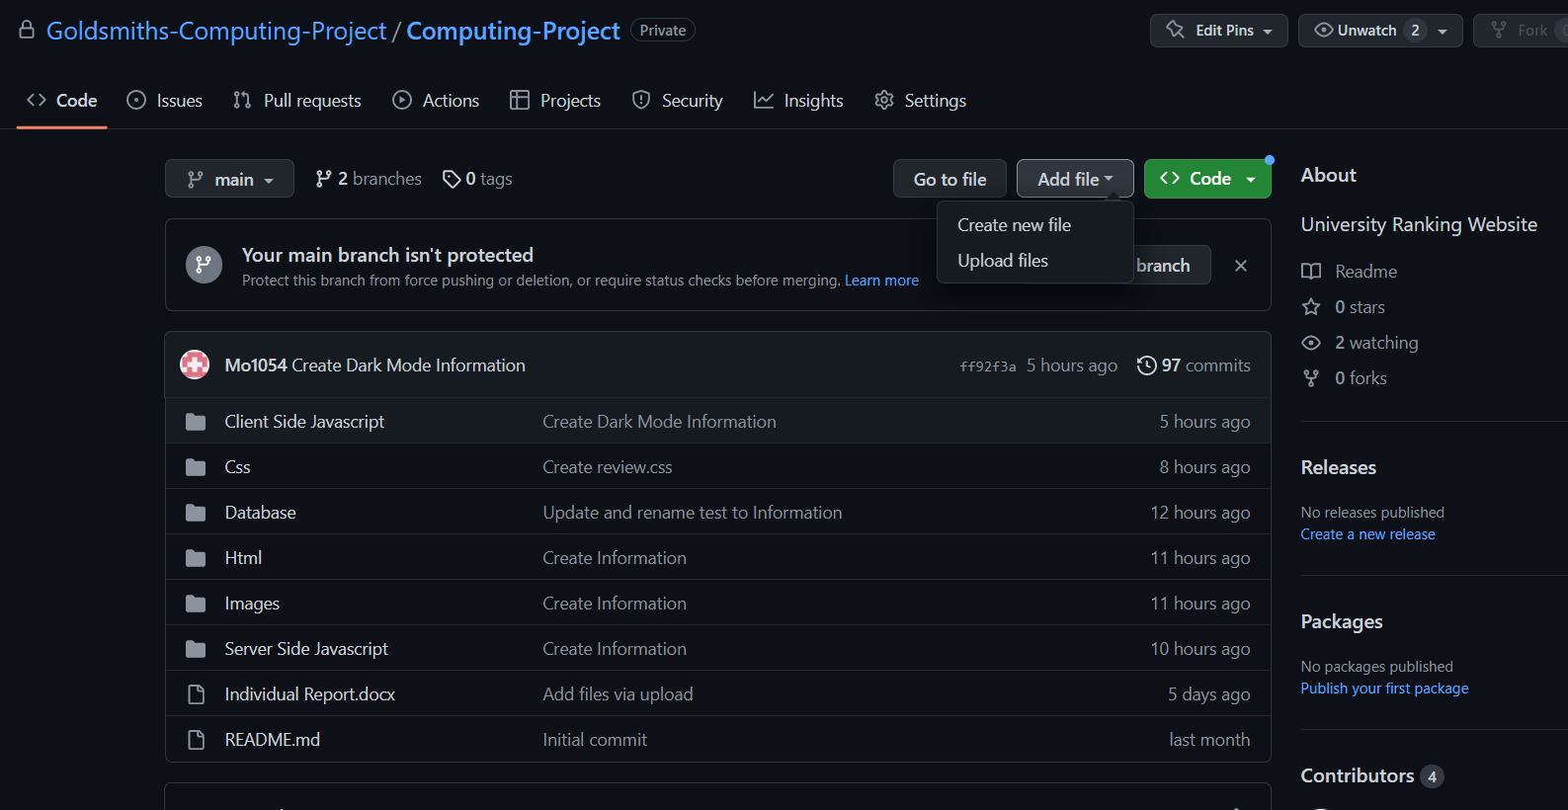

1. **RESEARCH & ANALYSIS PLANNING**

**3.1 Early Assumption Testing**

We achieved our early assumption testing in our proposal, in the form of evaluating our stakeholder and user needs, prior knowledge and market survey. Our market and stakeholder analysis explains our findings and how we built on them as part of our development process.

* 1. **Market Analysis**

To build our market analysis, we looked at other university ranking sites to give us an idea of what features are used that we could apply to our own application. We then created a comparison table to help us understand what features would be important for the user’s experience.

We referred to this table to decide what features to include and how it would look. We agreed that keeping the design of the site simple was important for ease of navigation for the user. If the user can navigate the site easily, it may make their experience more positive and encourage them to use the site again or recommend it to others. This decision was supported by the results from our questionnaire regarding the use of ranking sites.

In our questionnaire we asked our subjects 6 questions relating to using university ranking sites.

The results relating to the design and navigation were as follows, based on 20 subjects.

* 1. **Stakeholders Analysis**

We initially identified our main stakeholders to be college leavers, or those returning to education, we achieved this through creating user profiles.

The user profiles will help us to keep in mind who we are building this web application for. We don’t want to get distracted with building features that are not necessary to the user’s needs. Now that we are in the process of building the application, we have identified further stakeholders.

Developers

The developers will be responsible for building and maintain the application. Where we are the developers who will be working on this project, we want to keep our deliverables realistic and achievable based on our current skill levels. ***\*What skills do we have to build this project\****

Testers

The testers will be used at different stages of the development process, for example the design stage and for user testing. They will mostly be made up of our friends and family, and their feedback will help us identify any barriers, how we can resolve them and if we are on track to meeting our MVPS.

**3.4 Design Heuristics**

When thinking about design heuristics we wanted to make sure that our web application met the following criteria by achieving the following targets below. By using design heuristics, we can approach problems in a systematic way and generate solutions that are more likely to meet the needs of users and stakeholders. This should result in a better design outcome.

Simplicity

We want to keep the design of our web application simple, so that it is more accessible and easier to understand and navigate for the user.

Feedback

The design should provide clear feedback to the users, to help them understand the impact of their actions whilst navigating the site and how the system works.

Affordances

We want to ensure that the interface is clear and intuitive to the user.

Consistency

This is an important aspect of our design, it needs to be consistent in its colours, typography, and layout, to create a unified and cohesive visual expression.

Error prevention

We want our design to guide users towards correct actions and prevent mistakes, this ties in with the simplicity; having an easy to navigate system will help prevent errors by the user.

1. **APPLICATION REQUIREMENTS**

**4.1 Functional Requirements**

Functional requirements are a set of specifications that define what a software system should so. These requirements will describe the functions, capabilities and features our system must have to meet the needs of its users. As we move through iterations of the development, the requirements may change. Sections marked * will only be implemented should the initial MVPs be met.

**4.1.1 System Requirements**

We are creating a responsive web application that will be accessible to users via a browser on PC or smart phones, there are also no hardware requirements. The site will be accessible to users with disabilities, adhering to standards such as Web Content Accessibility Guidelines (WCAG). Further information on this can be found at <https://www.w3.org/WAI/standards-guidelines/wcag/>

**4.1.2 User Requirements**

Here we outline how users will interact with the web application, and the requirements needed to achieve a fluid user experience.

Navigation

* The site will be easy to navigate, there will be clear and intuitive menus, search bar, and other navigation tools to allow the user to quickly find the information they need.

Homepage

* The user can see the rankings list in full, this will be sorted by overall score by default.
* The user can sort the ranking according to either, Overall, Student Satisfaction, Graduate Prospects, Social.

Forum Page

* The user can view and engage in discussions with other users, about topics posted to the forum.

Review Page

* The user will be able to read, and post reviews and ratings of the universities, academic programs, social aspects, and other relevant topics.

Sign up Page*

* The user will be able to register a profile to the site, using their university credentials, they will then be able to log in via a username and password. This will allow them to submit reviews and ratings.

Contact Page

* Users will be able to see the contact details for the ‘owners’ of the web application, this will include email, telephone, and written address.

Privacy Policy

* Users can see a clear privacy policy that outlines how user data is collected, used and protected.

**4.2 Non-functional Requirements**

These are the characteristics that are not related to specific functions or features, but rather quality, performance and user experience.

Usability

* The site will be user friendly and easy to navigate, with clear and intuitive interfaces.
* The main language will be English, with easy to understand words and sentences.
* Visual aspects of the site will be appealing and consistent throughout the site.

Reliability & Performance

* The site will be reliable and available to the user for access, with minimal downtime or outages.
* The site should perform quickly and efficiently, with minimal load and response times.

Security

* The site will be secure, with measures in place to protect user data and prevent unauthorised access.
* User will be required to enter their university credentials to set up their profile.
* All users will have a unique ID
* Passwords are created upon setting up their profile, this is never displayed in the application.

Accessibility

* As stated previously, the site should be accessible to users with disabilities, adhering to WCAG.

Maintainability

* The site will be designed to be easy to maintain and update, with clear and well documented code.

Compliance

* The site should comply with the relevant laws and regulations relating to privacy, data protection and security.
* Inappropriate and offensive content will be filtered.

1. **PROTOTYPING & ITERATION**

**5.1 Concept**

As outlined in the proposal, the objective of this project is to develop a web application that ranks universities in London; to help users choose a place of study that suits them best. The website will focus on ranking by social aspects such as crime, transportation, and societies. In addition, there will be rankings by academic specifications such as courses, modules, and lecturers.

We have kept in line with our initial concept but made a few changes to how many categories we will aim to develop; these are outlined in our main MVPs. Some of the iteration processes for each MVP are detailed below.

* 1. **User Interface**

*\*First iteration of the user page\**

**5.3 Homepage**

First iteration of the Homepage.

\**What the group feedback was, how we improved it\**

**5.4 Forum page**

First iteration of the Forum page.

\**What the group feedback was, how we improved it\**

**5.5 Reviews**

First iteration of the Review page.

\**What the group feedback was, how we improved it\**

1. **SYSTEM DEVELOPMENT**

**6.1 Agile Project Techniques**

* 1. **Development of Source Code**

**6.2.1 Front-End**

**6.2.2 Back-End**

**6.2.3 APIs**

**6.2.4 Data Structures**

**6.3 Test-Driven Development**

**6.4 Unit Tests**

**6.5 TDD Practice**

1. **DISCUSSION**

**7.1 Thematic based analysis**

* 1. **Concept based analysis**

1. **EVALUATION**

**8.1 Technical Difficulties**

* 1. **Teamwork and Management**
  2. **Aims Reached**
  3. **Going Forward**

1. **CONCLUSION**

Summarise the outcome of the project, explaining the achievements and missed targets. How does this fit in a dynamic workflow and what impact does it have on the stakeholders or users?

**9.1 Individual reflection**

*\*Write your personal reflection here\**

1. **USER GUIDE**